What is Spring boot?
Sprint boot is a Java-based spring framework used for Rapid Application Development (to build stand-alone microservices). It has extra support of auto-configuration and embedded application server like tomcat, jetty, etc.

What is RAD Model?
RAD Model or Rapid Application Development model is a software development process based on prototyping without any specific planning. In RAD model, there is less attention paid to the planning and more priority is given to the development tasks. It targets at developing software in a short span of time.
SDLC RAD modeling has following phases
Business Modeling,
Data Modeling
Process Modeling
Application Generation
Testing and Turnover
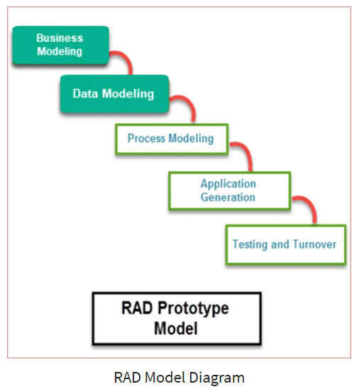
It focuses on input-output source and destination of the information. It emphasizes on delivering projects in small pieces; the larger projects are divided into a series of smaller projects. The main features of RAD modeling are that it focuses on the reuse of templates, tools, processes, and code.
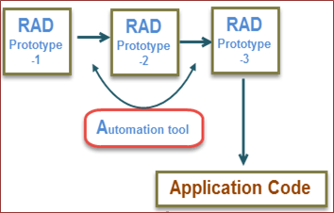

Features of Spring Boot that make it different?
- Creates stand-alone spring application with minimal configuration needed.
- It has embedded tomcat, jetty which makes it just code and run the application.
- Provide production-ready features such as metrics, health checks, and externalized configuration.
- Absolutely no requirement for XML configuration.

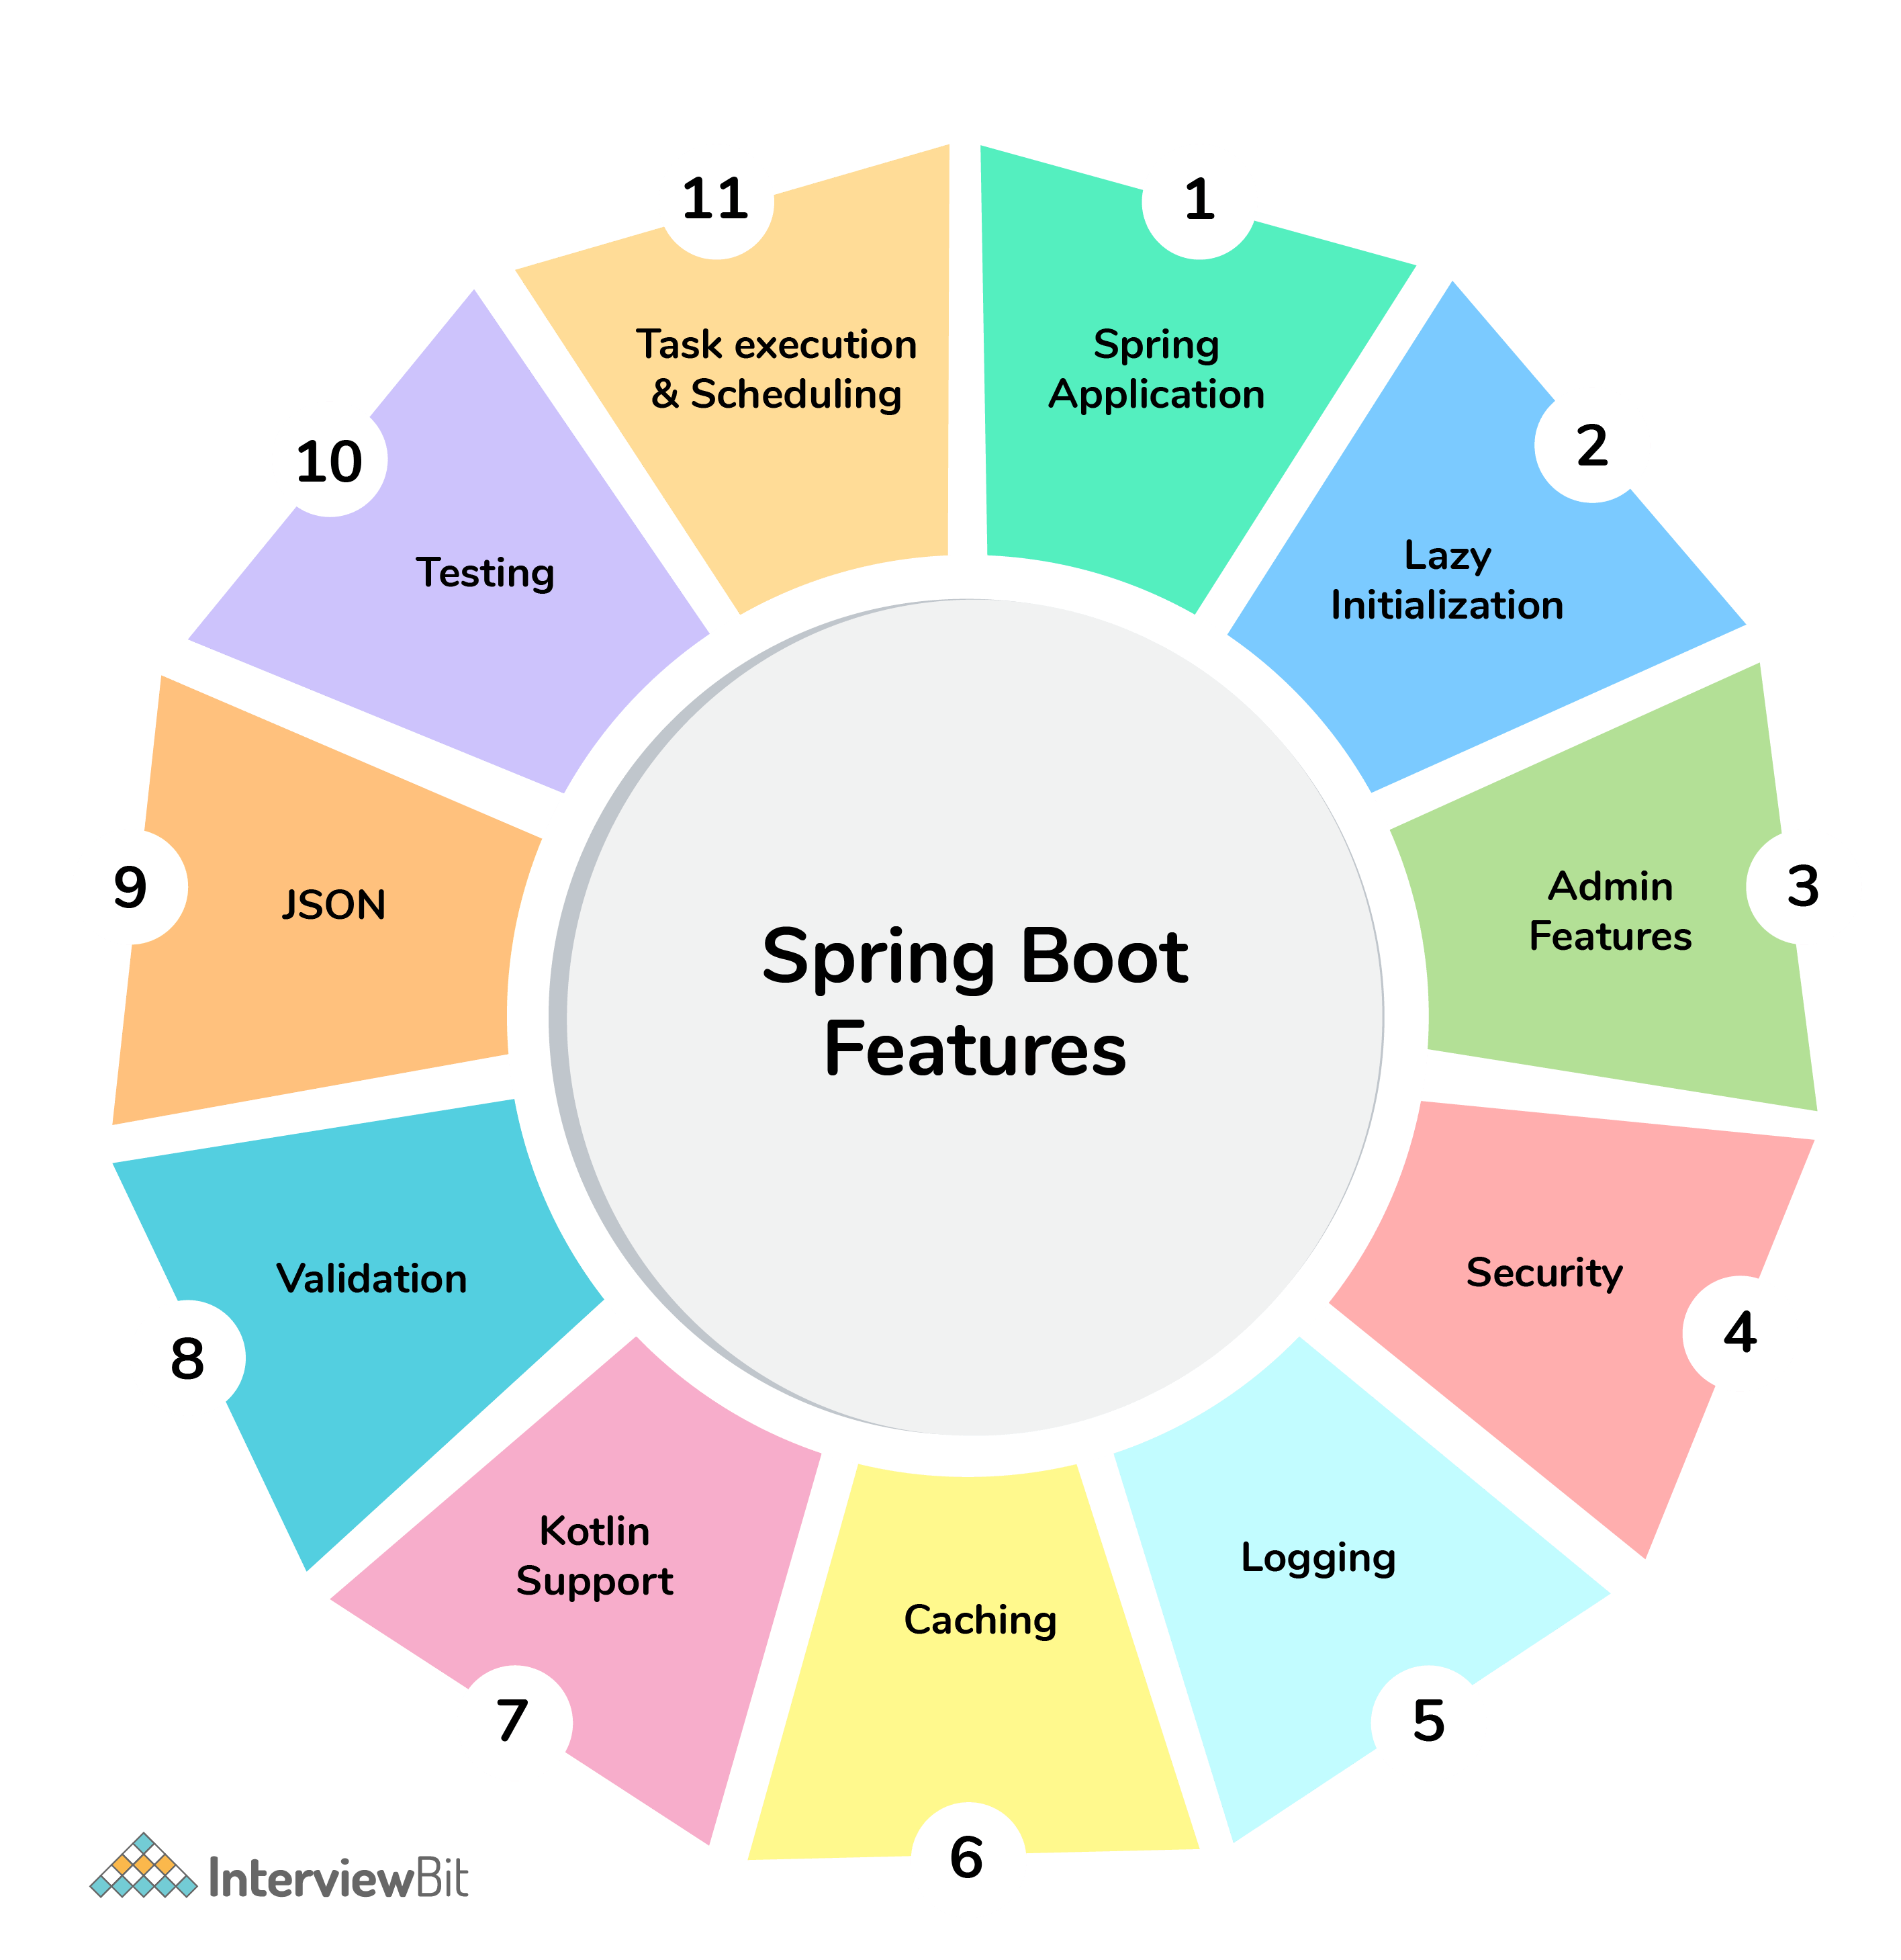

1. What are the advantages of using Spring Boot?
The advantages of Spring Boot are listed below:
- Easy to understand and develop spring applications.
- Spring Boot is nothing but an existing framework with the addition of an embedded HTTP server and annotation configuration which makes it easier to understand and faster the process of development.
- Increases productivity and reduces development time.
- Minimum configuration.
- We don’t need to write any XML configuration, only a few annotations are required to do the configuration.

2. What are the Spring Boot key components?
Below are the four key components of spring-boot:
- Spring Boot auto-configuration.
- Spring Boot CLI.
- Spring Boot starter POMs.
- Spring Boot Actuators.

3. Why Spring Boot over Spring?
Below are some key points which spring boot offers but spring doesn’t:
- Starter POM.
- Version Management.
- Auto Configuration.
- Component Scanning.
- Embedded server.
- InMemory DB.
- Actuators
Spring Boot simplifies the spring feature for the user:
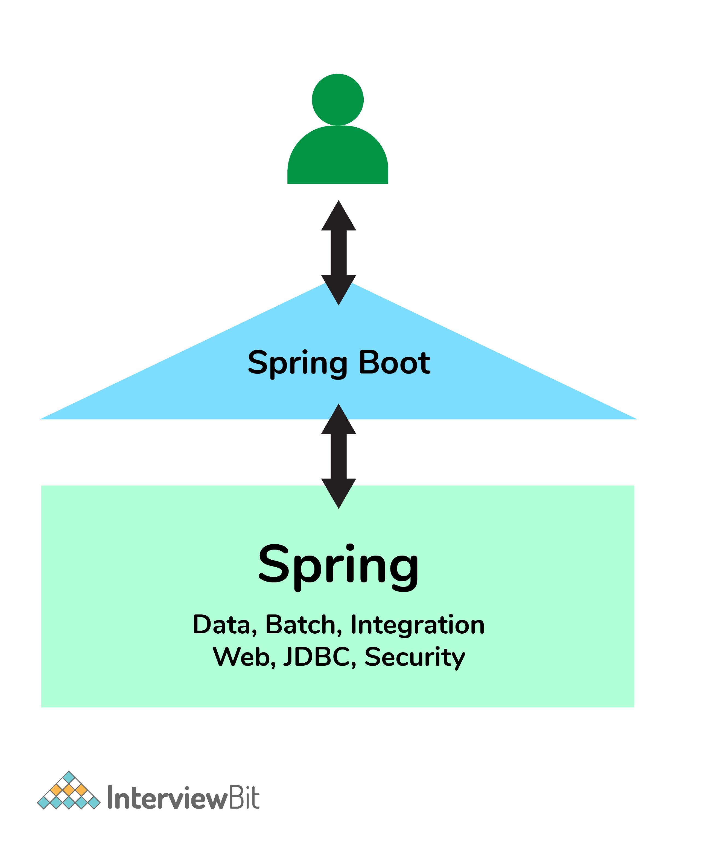

Different Phases of RAD Model
There are following five major phases of Rapid Application Development Model
RAD Model Phases | Activities performed in RAD Modeling
Business Modeling | - On basis of the flow of information and distribution between various  business channels, the product is designed
Data Modeling | - The information collected from business modeling is refined into a set of data objects that are significant for the business
Process Modeling | - The data object that is declared in the data modeling phase is transformed to  achieve the information flow necessary to implement a business function
Application Generation | - Automated tools are used for the construction of the software, to convert  process and data models into prototypes
Testing and Turnover | - As prototypes are individually tested during every iteration, the overall  testing time is reduced in RAD.

5. How does Spring Boot works?
Spring Boot automatically configures your application based on the dependencies you have added to the project by using annotation. The entry point of the spring boot application is the class that contains @SpringBootApplication annotation and the main method.
Spring Boot automatically scans all the components included in the project by using @ComponentScan annotation.

6. What does the @SpringBootApplication annotation do internally?
The @SpringBootApplication annotation is equivalent to using @Configuration, @EnableAutoConfiguration, and @ComponentScan with their default attributes. Spring Boot enables the developer to use a single annotation instead of using multiple. But, as we know, Spring provided loosely coupled features that we can use for each annotation as per our project needs.

7. What is the purpose of using @ComponentScan in the class files?
Spring Boot application scans all the beans and package declarations when the application initializes. You need to add the @ComponentScan annotation for your class file to scan your components added to your project

8. How does a spring boot application get started?
Just like any other Java program, a Spring Boot application must have a main method. This method serves as an entry point, which invokes the SpringApplication#run method to bootstrap the application.
@SpringBootApplication
public class MyApplication {

public static void main(String[] args) {

SpringApplication.run(MyApplication.class);
// other statements
}
}

9. What are starter dependencies?
Spring boot starter is a maven template that contains a collection of all the relevant transitive dependencies that are needed to start a particular functionality.
Like we need to import spring-boot-starter-web dependency for creating a web application.
<dependency>
<groupId> org.springframework.boot</groupId>
<artifactId> spring-boot-starter-web </artifactId>
</dependency>

10. What is Spring Initializer?
Spring Initializer is a web application that helps you to create an initial spring boot project structure and provides a maven or gradle file to build your code. It solves the problem of setting up a framework when you are starting a project from scratch

